***First in: the work presented in this report is my own and the data was obtained by my lab partner and me during the lab period***

**Report**

1. **Subject frame:**

In the second laboratory session announced by Mr. Abd El Bacet MHAMDI, we focused a little more on the method applied by Matlab on fuzzy logic.

At the beginning of the session we started to learn step by step how to create a graphical interface (GUI) on Matlab. It is the interface of software designed to perform such tasks. In our case the graphical user interface (GUI) is used to read customer reviews in a restaurant regarding the service and the food served by the restaurant, then the software must calculate by itself the tip percentage that one must give to the server.

This execution is done in 3 parts, first you have to read the customer evaluation using the graphical interface, then you make a direct transfer of information to the fuzzy inference system (FIS), after the decision will be made by the system, the result will be displayed directly in the graphical interface. Below is an explanatory diagram of how to transfer data.

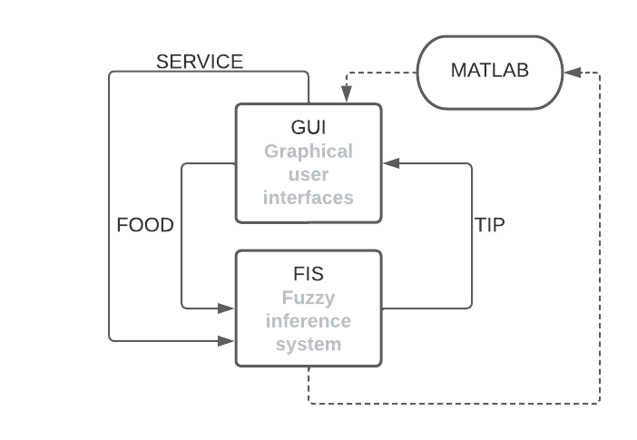

1. **Software programming:**

For the creation of the graphical interface using Matlab you must first type "guide" then choose "Blank GUI" then we can create the interface at our own choice, we must check some important configurations such as the “Tag”. We must ensure that the execution button is a "Callback function", this is to program it on exit as the following function 'function pushbutton_callback(hobject,eventdata, handles)'. Then we have to go to the programming of our brain, it's the fuzzy inference system, to program it we have to call the "Fuzzy Logic designer" then we have to adjust the inputs, outputs of the system according to an expert or a notebook load well defined, after all that remains is to define the rules in this system, we must inform the system how to react so that it can provide us with a result at the exit. In the end, we only have to export the file “. Fis" then call it in the Matlab program using the following instructions:

Fis = readfis(‘name_file_.fis’)

* output_variable=evalfis (fis, [inputs…]).

1. **Code:**

For the rest of our tipping program we must follow the following instructions:

- created the fuzzy inference system.

- Created the graphical interface.

- Adjust buttons and text boxes.

- Read the evaluation values ​​(Food & service).

- Convert them into numbers.

- Read the file that includes the fuzzy inference system.

- Evaluate the output variable using the FIS.

- Convert the obtained value to String.

- Show finished value in GUI.

The program is as follows:

food= get(handles.food,"string");

food=str2num(food);

service=get(handles.service,"string");

service=str2num(service);

fis=readfis("calcul.fis");

tip=evalfis(fis,[food,service];

tip=num2str(tip);

set(handles.tip,"string",tip);

*Laboratory honor pledge*

*Imhamed boujemaa*